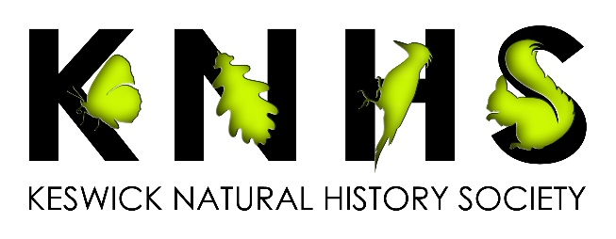

Website: www.keswicknathist.co.uk

NEWSLETTER August 2023

Welcome to our newsletter revealing the programme for the coming season and a summary of the last year.

Details about how to join or renew your membership are at the end of the newsletter.

Please contact Tony Marsh with any comments or ideas for the Society either at a meeting or via e-mail: marshlambl@aol.com.

Indoor Lecture Programme 2023/24

All meetings are held in The Crosthwaite Parish Room, Keswick on a Thursday evening, commencing at 7.30 pm. Free to members but non-members are very welcome with a £4 entry fee.

We would like to reintroduce the reporting of interesting nature sightings at the start of each meeting. If you have observed something noteworthy, or perhaps the first sighting of the year, e-mail Tony Marsh, (see above), and we can let the membership know.

Oct 5 Chris Winnick Butterflies of Cumbria
Chris is the Chair of Butterfly Conservation, Cumbria branch. His presentation will focus on the work of Butterfly Conservation and the species found in Cumbria.

Oct 19 Jack Brennand Peatland Conservation
Jack works for the University of Cumbria and partners with a local company to evaluate blanket peatland restoration projects using innovative 3D X-ray CT scans. He will explain his work and tell us how it is helping to provide a nature-based solution to the climate crisis.

Nov 2 Jackie Foott Red Squirrel Conservation
Jackie has been involved in red Squirrel conservation in the UK for over 30 years. She now runs British Red Squirrel, a UK based information hub. She will talk about conservation of red squirrels both locally and nationally.

Nov 16 Kevin Scott Cumbria Wildlife Trust - Our Local Reserves
Kevin is Cumbria Wildlife Trust’s Northern Reserves Manager. He will be talking to us about the Cumbria Wildlife Trust reserves at Eycott Hill, near Berrier, Penrith and at Dubbs Moss, near Cockermouth.

Nov 30 Phillip Munro Supporting Golden Eagles in South Scotland
Philip works for the South of Scotland Golden Eagle Project and will tell us about the projects work reinforcing the small Golden Eagle population in Southern Scotland.

Jan 11 Alan Smith What the Ice-age did for Keswick
Ex-chairman of KNHS, Alan, will discuss how the Ice-age shaped the foundations of our natural world, and how it affected the flora and fauna in our local area.

Jan 25 Julia Hoggard Bees and Hay Meadows
Julia is an experienced beekeeper from the Kendal area. She is the education officer for Kendal & South Westmorland Beekeepers’ Association and runs BeeEd, a not-for-profit organisation. Her talk about bees and hay meadows will include advice about how we can develop a mini garden hay meadow at home and look at the way flowers and pollinators interact.

Feb 8 Stuart Sharp Ecology and Conservation of River Birds
Stuart works for Lancaster University’s Environment Centre, a teaching and research facility, where he carries out long-term studies of our river birds. He will talk to us about his research on these species, covering aspects of their behavioural and population ecology, and the conservation challenges they face.

Feb 22 Stephanie Johnstone Pine Martens
Stephanie Is Chair of the Dumfries and Galloway Pine Martens Group and has most recently been working on pine marten conservation in various locations in Scotland England and Wales for the Vincent Wildlife Trust. She will talk to us about the history and ecology of pine martens in Britain and current conservation efforts for the species.

March 7 AGM
The AGM will be followed by a talk and slide show by the Chair of KNHS, Tony Marsh. Using his photographs, he will share experiences from all of the recent KNHS field trips.

Field trips 2023-24

The programme of outings is not currently finalised but will include our traditional visits to a Wetland and Wildfowl Trust reserve, probably Martin Mere in Lancashire in the late Autumn, as well as RSPB Leighton Moss

Outings will be notified via the website and e-mail to members at least two weeks before the event.

Tony Marsh is the contact for all outings. Please get in touch by email at marshlambl@aol.com (or if you’re not on email tel. 72137 or 07974 909522) with him by two days before the outing so that he can organise car sharing. We recommend drivers are reimbursed on the following basis:-

0 – 20 miles: £3 per passenger
21 – 40 miles: £4
41 – 60 miles: £5
61 – 80 miles: £6
Over 80 miles: £7
(It might be prudent for drivers to check with your insurance company that this payment of expenses will not interfere with their insurance cover)
Guests are welcome but we regret no dogs.

Reports for Field Trips 2022-23

2022

October 22
Martindale
A wet morning in Bannerdale, on the far side of Ullswater observing Red Deer in the valley below and the fellsides above. Dropped into Aira Force on the way back to see the falls in full spate and autumn colour.

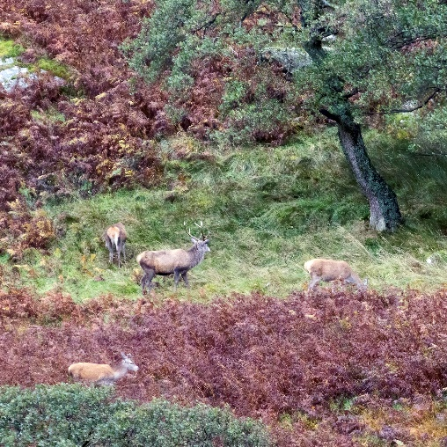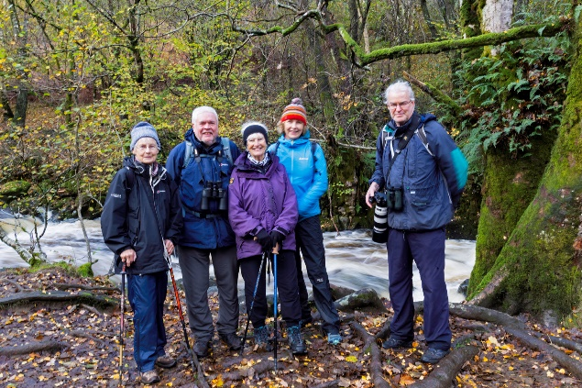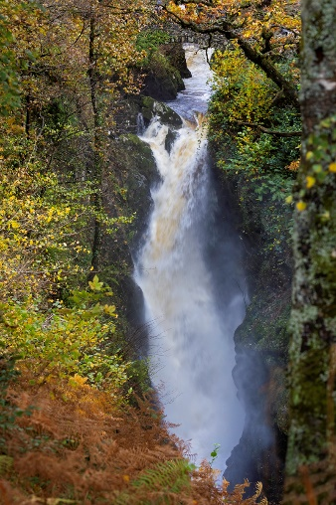

December 22
Caerlaverock
Our traditional visit to this WWT reserve on the Scottish side of the Solway. The daily feeding of wild Whooper Swans just outside the Peter Scott hide is always a highlight but many other wildfowl species seen together with numerous Snipe, (seen flying in the photograph), smaller birds such as Yellowhammers and Tree Sparrows and Roe Deer. A female Hen Harrier at the end of the day.
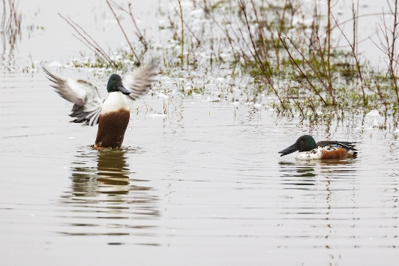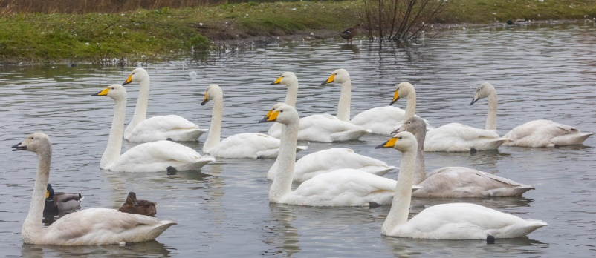

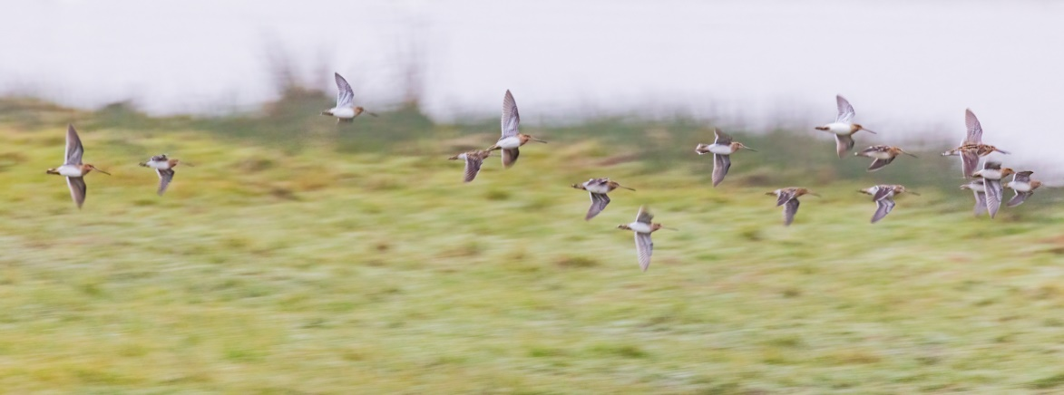

2023
April 23
Sizergh Car Park with Park End, Foulshaw and Leighton Mosses
Disappointing not to connect with Hawfinch in the Sizergh Castle car park but the nearby Park End Moss, a relatively recently developed reedbed area delivered views of Kingfisher and the sounds of a booming Bittern amongst other things in lovely light, (see Little Egret photograph).
Next stop was to Cumbria Wildlife Trust Foulshaw Moss with marvelous views of Water Rails, the distant Osprey nest with an informative briefing about all things Osprey by one of the Trust volunteers and the first of the year’s singing Willow Warblers.
Finally, we dropped into RSPB Leighton Moss with highlights of Avocets, a glimpse of a low flying Bittern and a superb Male Marsh Harrier, seen flushing a Snipe in the photograph.

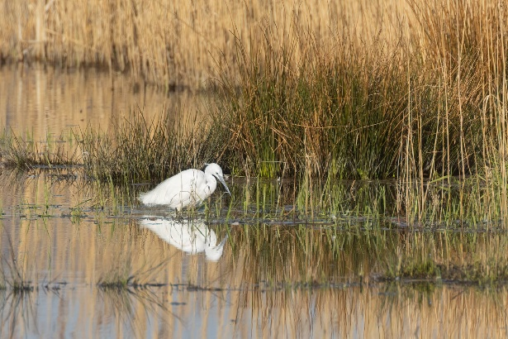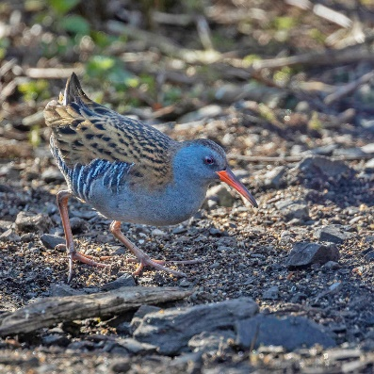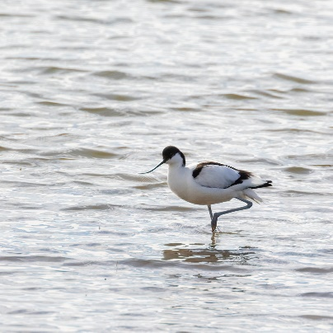

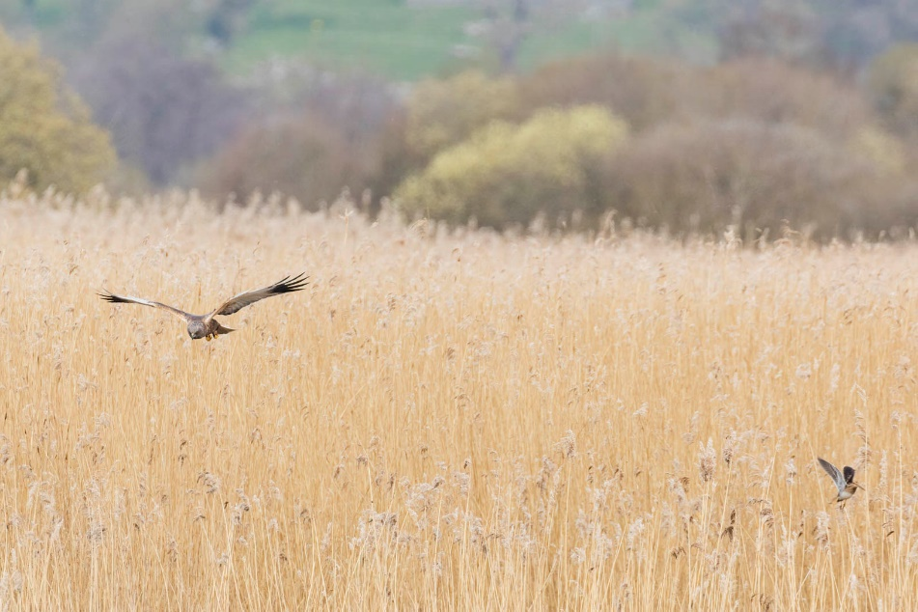

June 23

Whitbarrow
Torrential rain during our journey to Witherslack almost put us off embarking on this trip which was guided by Joe Murphy, Senior Reserves Officer for Cumbria Wildlife Trust, but our stoicism paid off as by the time we reached the top of this limestone hill the sun was fully out as were some spectacular butterflies, including Small Pearl Bordered and Dark Green Fritillaries, Common Blues, Northern Brown Argus and Ringlets. Joe pointed out a number of rare limestone specialist plants and explained how the reserve was being managed. A strange sight of half a dozen Grey Squirrels scampering back to the woods from out in a field ended the day.

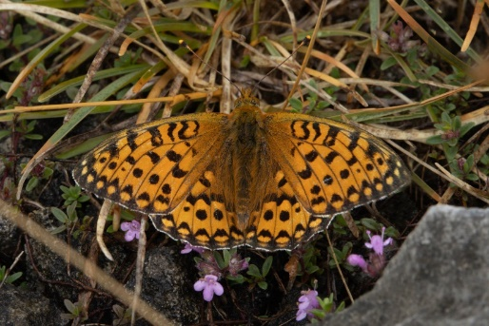 Dark Green Fritillary and Ringlet 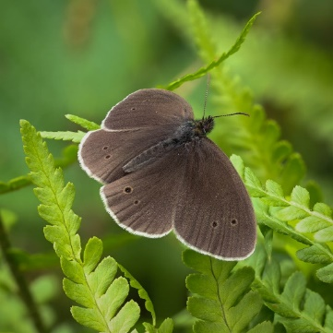
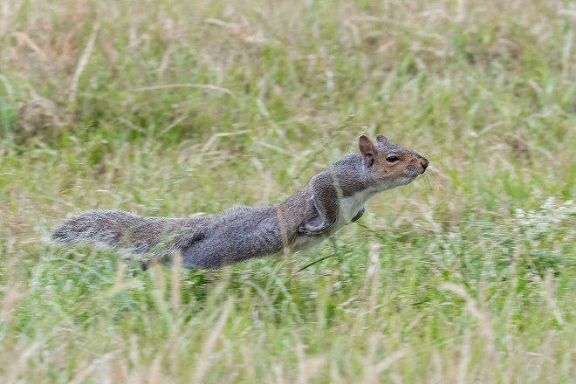

Penrith: Sand Lizard Breeding Programme
A visit to the Penrith home of Paul Hudson who has been raising Sand Lizards in south-facing garden and subsequently releasing them in coastal dune systems in North Wales and South Lancashire. His work is amazing and inspiring and we were delighted to see both males and females as they came out to sun themselves. The males were particularly stunning in their striking breeding colours.

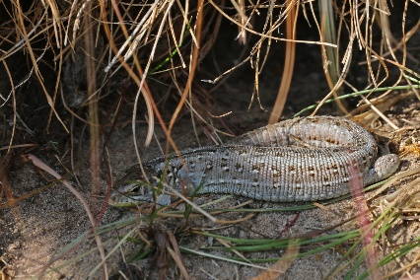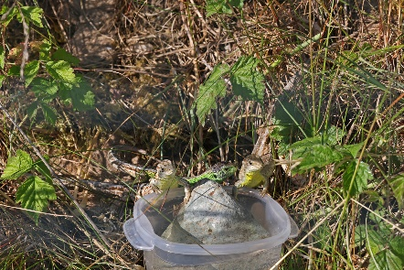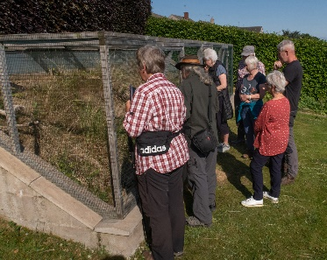

July 23
Lowther Estate

Jim Bliss, Conservation Manager of Lowther Estates gave an excellent talk to the Society last October about the conservation and regeneration programe on the estate, and this was an opportunity to see things first hand. After a recap of the work and philosophy behind it, Jim and Joe, his grassland ecology colleague showed us the enclosure where a pair of Beavers have been introduced, and although we did not see either of these predominantly nocturnal animals, there as plenty of evidence of feled trees etc. We also walked down to the river to see the changes made there and the hay meadows on the surrounding flood plain, where many butterflies such as Small Skippers were prominent. Finally, we looked at a breeding pair of White Storks that will be used as part of a reintroduction programme.

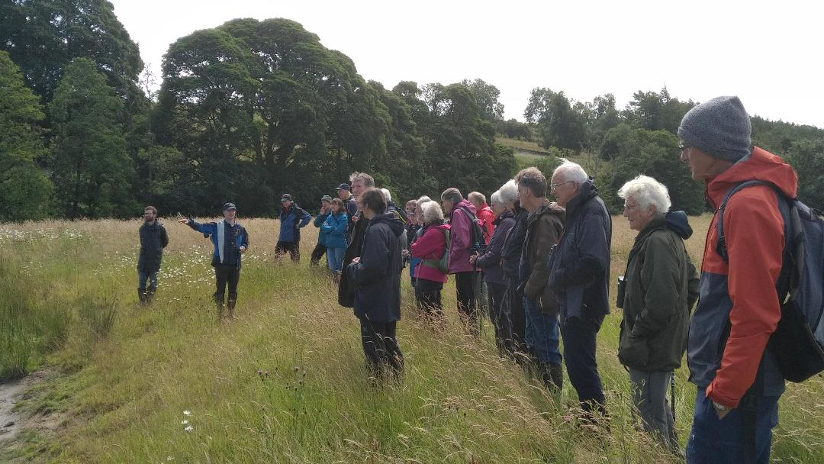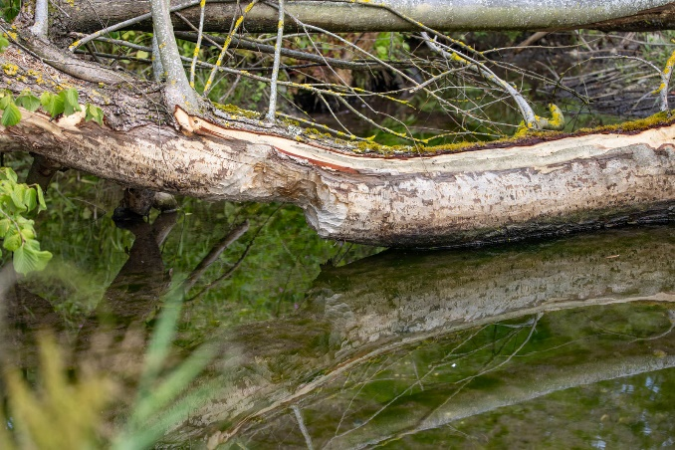

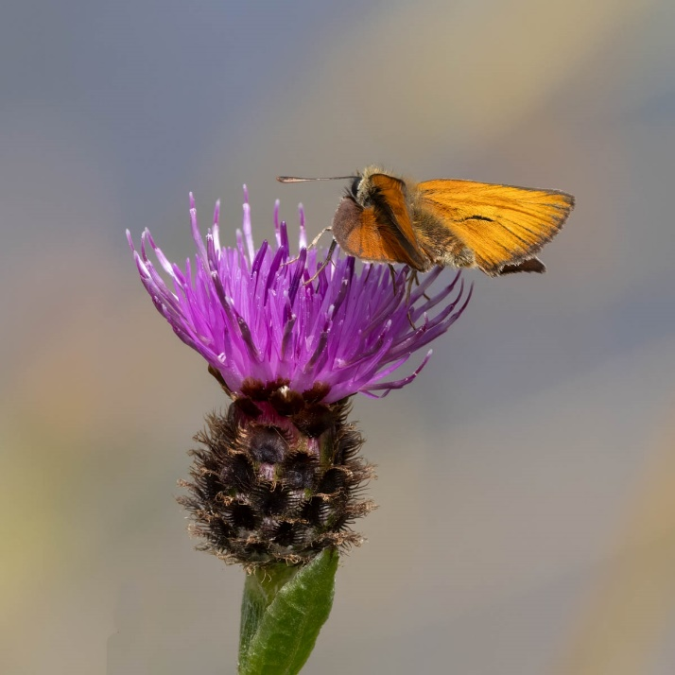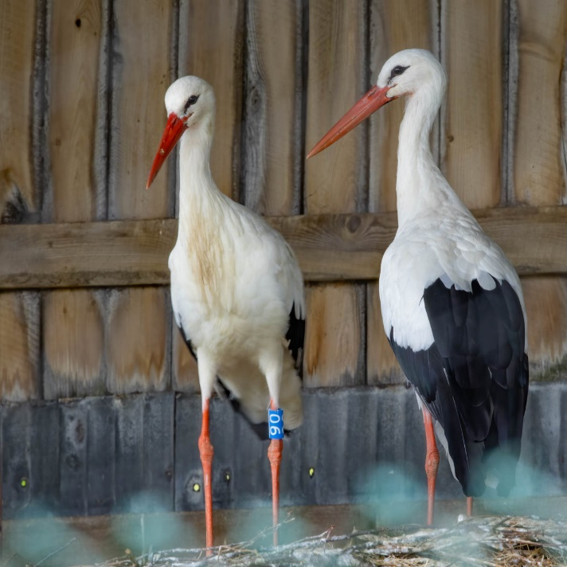

August 23
Spooney Green Moth Session

KNHS member and moth expert, (amongst other things), Peter Macqueen, talked us through the many moth species he had caught in a moth trap left overnight in the beautiful garden of KNHS members, Ian and Sandra Wallace, at the foot of Latrigg. Many thanks to Peter, Ian and Sandra.
(Bordered Beauty and Oak Hook-tip moths illustrated)

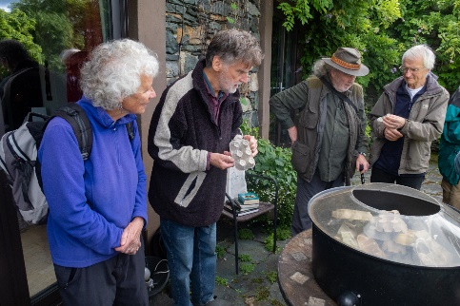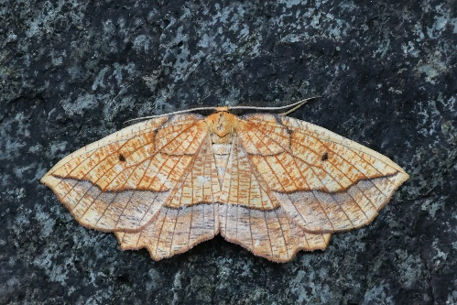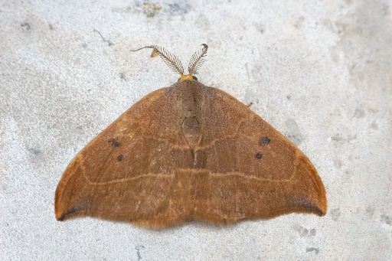

Membership Renewal for 2023/24

There are 3 possible ways of renewing your membership this year:

- Make a bank transfer to the Society’s account (£15 per person, Students and Juniors £5) –

Account No. 34055789, Sort Code 01-04-69.

Most importantly please enter your Surname as Reference and let Jean Gilbert know you have done so via e-mail on keswickvets@aol.com so that we can subsequently contact you.

- Fill in the Renewal Slip at the end of this newsletter and send a cheque by post to Jean Gilbert (Treasurer) Greta Bank Farm, Keswick CA12 4NS

- Come to a meeting and pay then, by cash or cheque.

KESWICK NATURAL HISTORY SOCIETY Membership & Renewal Slip 2023/24

NAME(S) ......................................................................................................................................................................

ADDRESS.....................................................................................................................................................
........................................................................................................................Post Code............................
Tel No...........................................
Email Address (please supply even if we have this already as this will confirm your permission for us to contact you for Data Protection purposes) ....................................................................................................
Amount Enclosed: Cash............... Cheque .................. (payable to Keswick Natural History Society)

